|  |  |
| --- | --- |
| **Ex No: 5** | Check whether a given number is Armstrong number or not |

**AIM**

Write a C program to check whether a given number is Armstrong number or not

$$Example: 3^{3}+ 7^{3}+ 1^{3}=371$$

Hence, 371 is the Armstrong number.

**PRE-LAB QUESTIONS**

1. What are library functions? Mention any four library functions in C
2. What are the logical operators available in C
3. Explain ternary operator
4. What is the purpose of type declaration in C
5. Differentiate assignment and equality

**ALGORITHM**

**Step 1:** Start  
**Step 2:**  read number A  
**Step 3:** If the sum of cubes of digits of A is equal to A,  
 print “Armstrong number”  
**Step 4:**  Else, print “Not an Armstrong number”  
**Step 5:** End

**FLOWCHART**

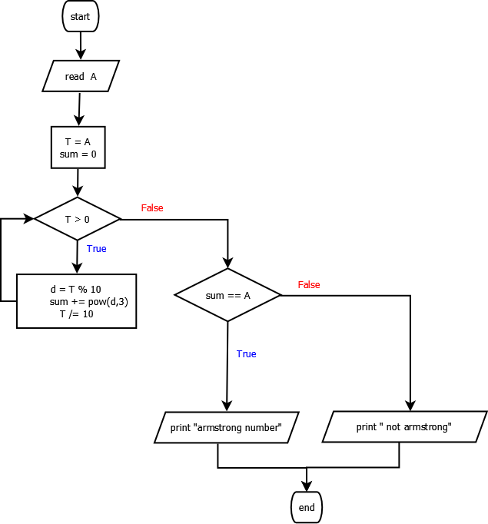

**PROGRAM**

#include<stdio.h>

void main**(){**

int A**;**

int sum **=** 0**;**

int T**;**

scanf**(**"%d"**,** **&**A**);**

T **=** A**;**

**while** **(**T **>** 0**)**

**{**

sum **+=** pow**((**T **%** 10**),**3**);**

T **/=** 10**;**

**}**

**if** **(** sum **==** A**)**

printf**(**"Armstrong number"**);**

**else**

printf**(**"Not an armstrong number"**);**

**}**

**INPUT**

**371**

**OUTPUT**

**Armstrong number**

**POST-LAB QUESTIONS**

1. Write the C program to find the sum of all odd integers between 1 and N.
2. Write the C program to reverse the given number

**RESULT**

Thus the C program to find the program to find whether the given year is leap year or Not has been written, executed and verified successfully.